

Nama : Azaria Cindy Sahasika

Nim : 2341760169 / 07

Kelas : 1G SIB

Lesson : Dasar Pemrograman

Material : Jobsheet 4

# JOBSHEET 4

**Pseudocode and Flowchart**

# Objective

After learning this topic, students must be able to:

* 1. Understand and explain the use of Pseudocode to model algorithms.
  2. Understand and explain the use of Flowchart to model algorithms by using graphical symbols.
  3. Design algorithm to solve the problem.
  4. Implement a program from Pseudocode or Flowchart that has been designed before.

# Laboratory

* 1. **Experiment 1: Pseudocode Experiment time: 40 minutes**

You are given the following pseudocode:

**Algorithm**: CircleStudentID

{input radius and calculate the circumference and area of the circle}

**Declaration**:

r : int

circumference, area : double

**Description**:

1. **print** “Input radius!”
2. **read** r
3. circumference = 2*3.14*r

4. area = 3.14 *r*r

1. **print** circumference
2. **print** area

Based on the pseudocode, the implementation steps are given as follows:

* + 1. Create a new Java file named **CircleStudentID.java.**
    2. Create the basic structure of Java program, including class and main () method!
    3. Import the Scanner class into your program.
    4. Create a variable or instance variable named **input** from Scanner in main () method.



* + 1. Declare variable **r** with **int** data type, and **circumference** and **area** with **double** data type.



* + 1. Input **r** from console by calling **nextInt()** method:

* + 1. After getting the **r** value, calculate the **circumference** and **area** by using the following formula:



* + 1. And finally, print the value of **circumference** and **area.**

* + 1. Compile the program, run and observe the result!

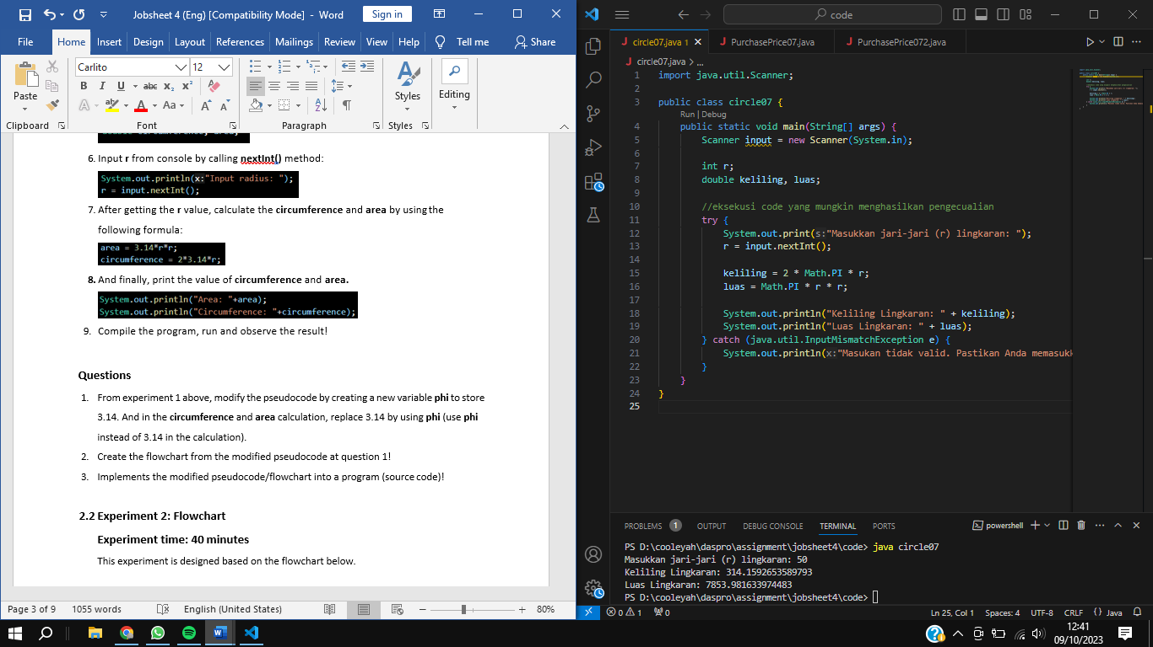

# Questions

1. From experiment 1 above, modify the pseudocode by creating a new variable **phi** to store

3.14. And in the **circumference** and **area** calculation, replace 3.14 by using **phi** (use **phi**

instead of 3.14 in the calculation).

1. Create the flowchart from the modified pseudocode at question 1!
2. Implements the modified pseudocode/flowchart into a program (source code)!

# Experiment 2: Flowchart Experiment time: 40 minutes

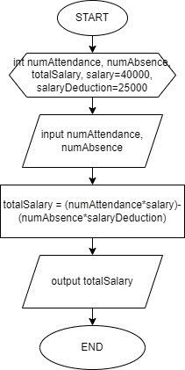This experiment is designed based on the flowchart below.

The following steps illustrate how to implement this in a Java program using the above flowchart.

* + 1. Create a new Java file named **SalaryStudentID.java**
    2. Create the basic structure for Java programming, including class and main() method.
    3. Import class **Scanner** into your program.
    4. Declare **input** variable from Scanner class inside main() method



* + 1. Create variable using **int** data type, named **numAttendance**, **numAbsence**, **totalSalary**, **salary** and **salaryDeduction**.



* + 1. Create input statement for **numAttendance** and **numAbsence**.

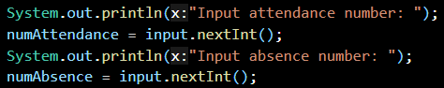

* + 1. Calculate **totalSalary** by using the following formula:



* + 1. Output the **totalSalary**



* + 1. Compile the program, run, and observe the result.

# Question!

1. Create a pseudocode based on the above flowchart and modify it by getting the **salary**

and **salaryDeduction** from the user input!

1. Implement the modified pseudocode in the above question, into a java program!
   1. **Experiment 3: Case Study Experiment time: 60 minutes** *Please look at the case study below!*

Mrs. Ani went shopping at the Office Supplies Store to buy notebooks. The price of a dozen notebooks is Rp. 25,000. Mrs. Ani bought 3 dozen notebooks because she has 3 children, and each of them was given 1 dozen. At that time, the office supplies store had a promotion where shoppers received a 10% discount. What is the total amount Mrs. Ani must pay? (*Assuming the price of notebooks per dozen and the number of dozens of notebooks purchased are* ***input*** *variables*). Please create a pseudocode, a flowchart, and implement the code!

* + 1. Pseudocode

**Algorithm**: NotebooksPurchasePriceStudentID

{input price, quantity and calculate the discount and total price}

**Declaration**:

price, quantity: int

discount=0.1, totalPrice, purchasePrice, totalDiscount : double

**Description**:

1. **print** "Input price!”
2. **read** price
3. **print** “Input quantity!”
4. **read** quantity
5. totalPrice = price * quantity
6. totalDiscount=totalPrice*discount
7. purchasePrice= totalPrice - totalDiscount
8. **print** “The total discount is ”
9. **print** totalDiscount
10. **print** "The Purchase Price is ”
11. **print** purchasePrice

From the above pseudocode, the flowchart is as follows:

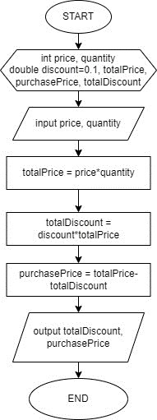

And if we implement into a program, the steps are as follows:

1. Create a new java file named **PurchasePriceStudentID.java**
2. Create a basic java program including the class and main() method
3. Import the Scanner class into your program.
4. Create **input** object from **Scanner** class inside main() method



1. Create variable **price** and **quantity** by using **int** data type, while **discount**, **totalPrice**, **purchasePrice** and **totalDiscount** from **double** data type.

1. Get the user input for **price** and **quantity** by using the following statements:

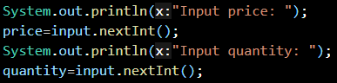

1. Then, calculate the **totalPrice**:



1. Calculate the **totalDiscount** by using the following formula



1. Do **purchasePrice** calculation by using the following statement.



1. Output the value of **totalDiscount** and **purchasePrice**

1. Compile, run and observe the result!

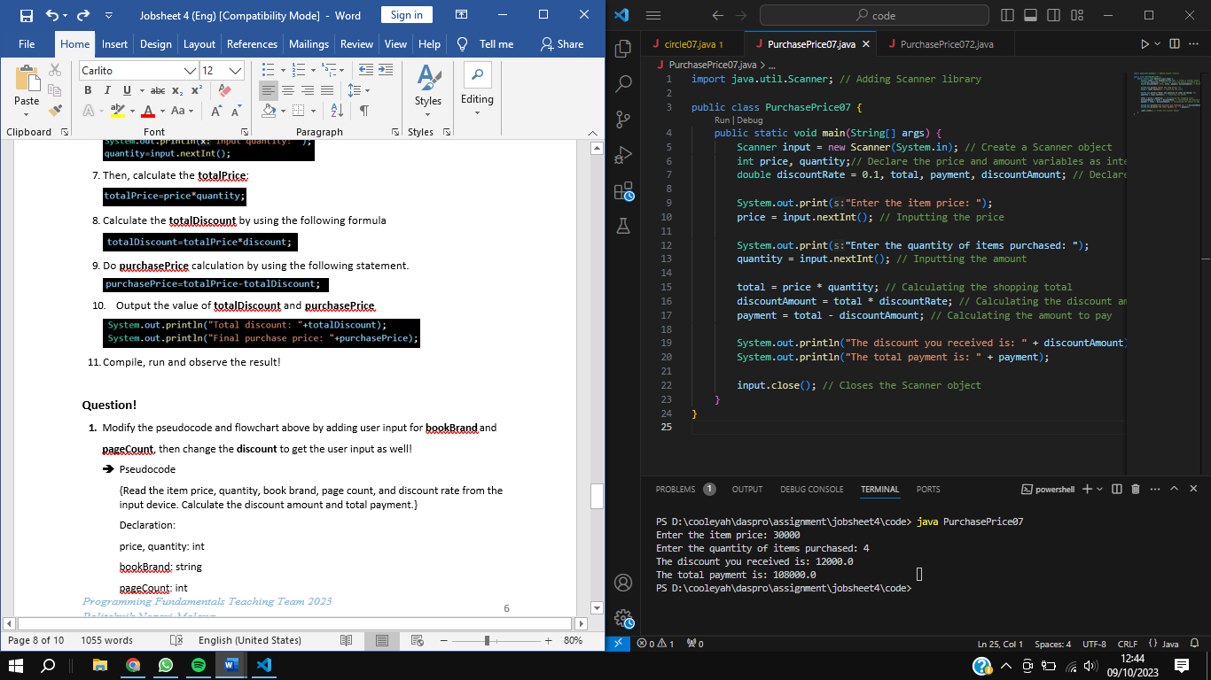

# Question!

1. Modify the pseudocode and flowchart above by adding user input for **bookBrand** and

**pageCount**, then change the **discount** to get the user input as well!

* Pseudocode

{Read the item price, quantity, book brand, page count, and discount rate from the input device. Calculate the discount amount and total payment.}

Declaration:

price, quantity: int

bookBrand: string

pageCount: int

discountRate: double

total, payment, discountAmount: double

Description:

* 1. Start
  2. Print "Enter the item price."
  3. Read price.
  4. Print "Enter the quantity of items purchased."
  5. Read quantity.
  6. Print "Enter the book brand."
  7. Read bookBrand.
  8. Print "Enter the page count."
  9. Read pageCount.
  10. Print "Enter the discount rate (in decimal form, e.g., 0.1 for 10%)."
  11. Read discountRate.
  12. total = price * quantity
  13. discountAmount = total * discountRate
  14. payment = total – discountAmount
  15. Print "Item: " + bookBrand
  16. Print "Page Count: " + pageCount
  17. Print "Discount Amount: " + discountAmount
  18. Print "Total Payment: " + payment
  19. Stop
* Flowchart

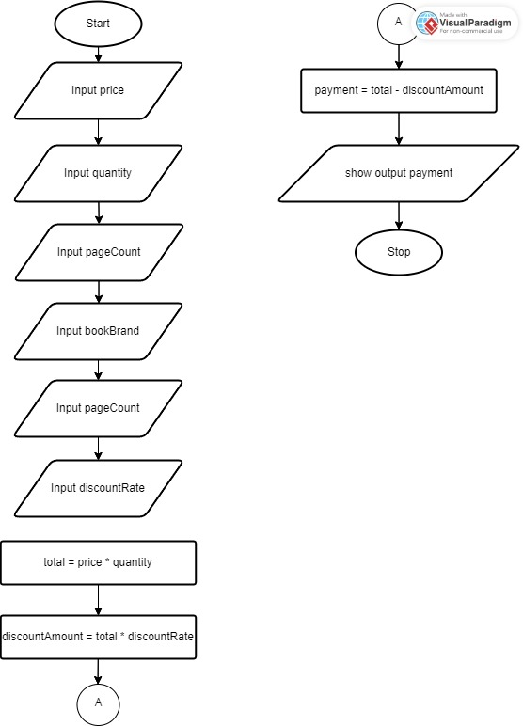

1. Implement the changes in a program!

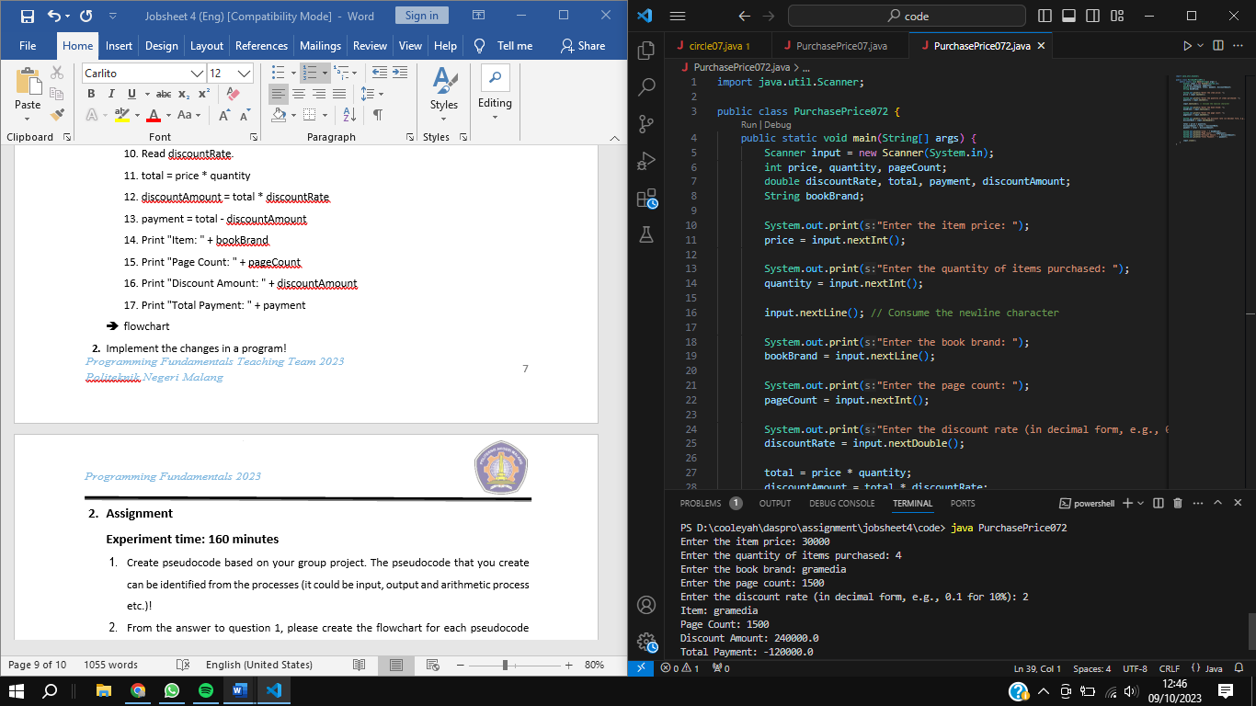

# Assignment

**Experiment time: 160 minutes**

* 1. Create pseudocode based on your group project. The pseudocode that you create can be identified from the processes (it could be input, output and arithmetic process etc.)!

Pseudocode :

1. Start.
2. Read String item_name.
3. Read Int quantity_items, price, total price.
4. Read Double discount = 0.075, total pay.
5. Print input item name.
6. Read item_name=input.nextLine().
7. Print item quantity input.
8. Read quantity_item=input.nextInt().
9. Print item price input
10. Read price=input.nextInt().
11. Start the IF statement.
12. IF STATEMENT: If the quantity of goods input is less than 0 then error.
13. IF: If the item price is less than 100 then error.
14. Discount calculation = total price * discount.
15. Total payment calculation = total price-discount.
16. Stop
    1. From the answer to question 1, please create the flowchart for each pseudocode that is already created!

Flowchart :

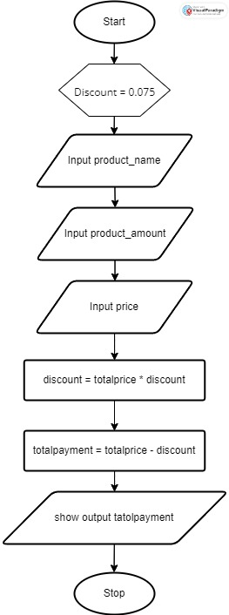

* 1. Implement the pseudocode/flowchart into a program. Please make a note that the program will only include input, output, variable declarations, arithmetic operation (and any other operator). Since we haven’t reached condition selection, looping, method, array, then you do not have to use it right now.

Code and Output :

